**COCA Corpus Analysis**

1. **Michael Jordan**

Frequency of this word is 3163

We can also analyse that, there are many sections where this name has been occurred like, in BLOGs: 133 times

WEB: 155 times

TV/Media: 219 times

Spoken: 658 times

NEWS: 1269 times

Academy: 29 times

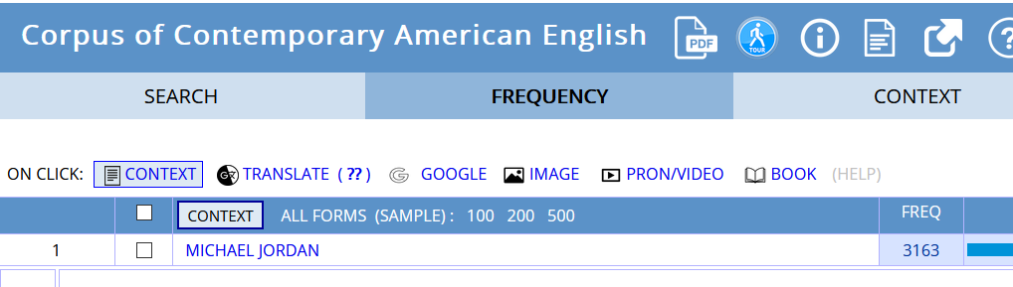

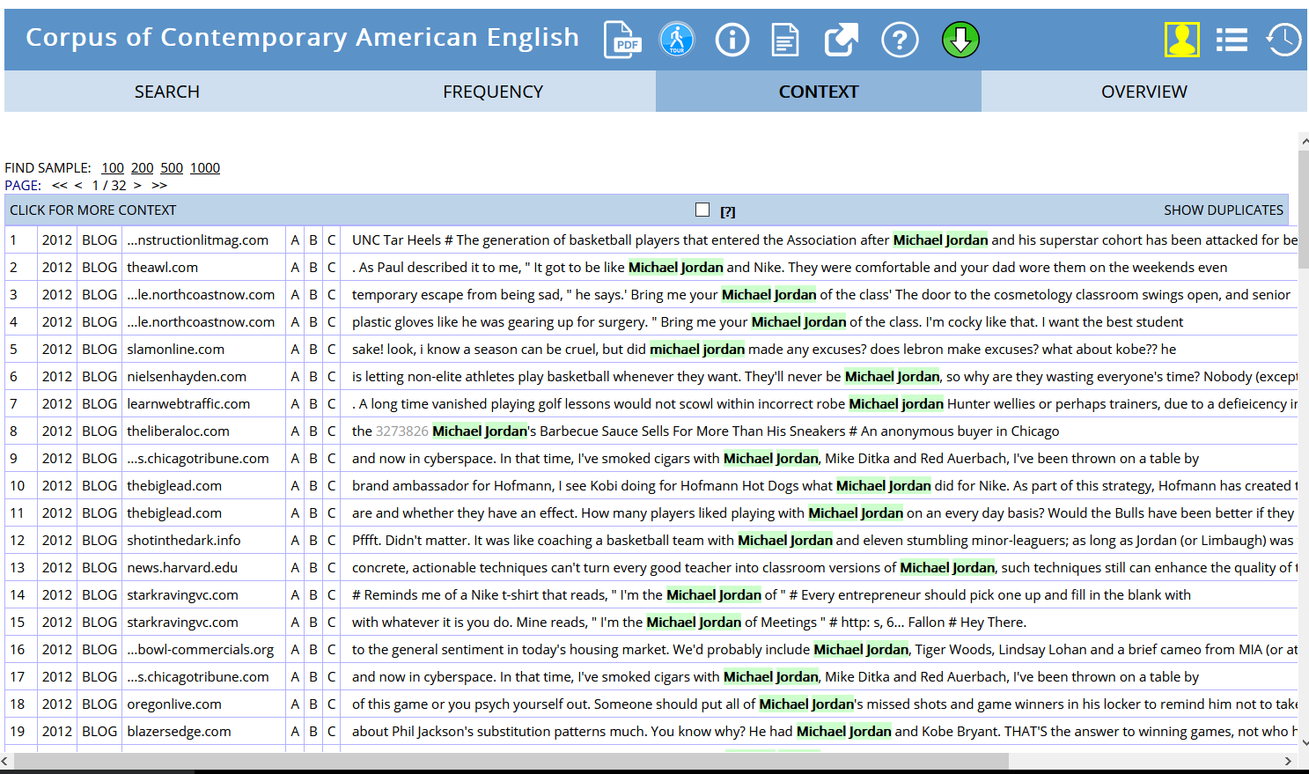

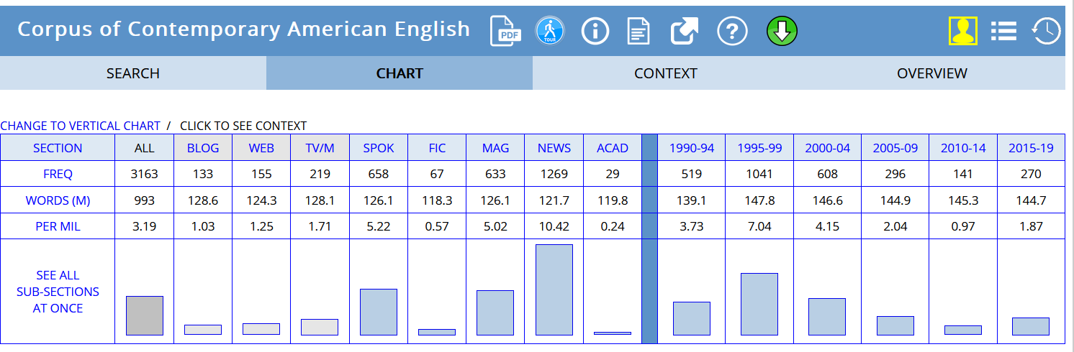

1. **Tiger Woods**

Frequency of this word is 2794

We can also analyse that, there are many sections where this name has been occurred like, in

BLOGs: 165 times

WEB: 147 times

TV/Media: 93 times

Spoken: 646 times

NEWS: 995 times

Academy: 20 times

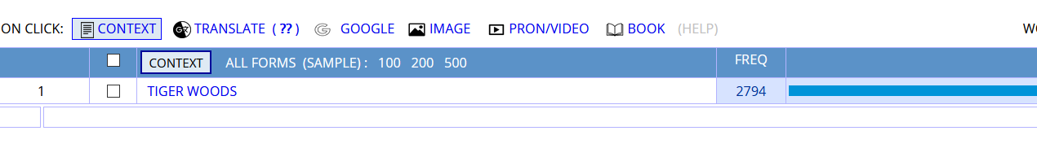

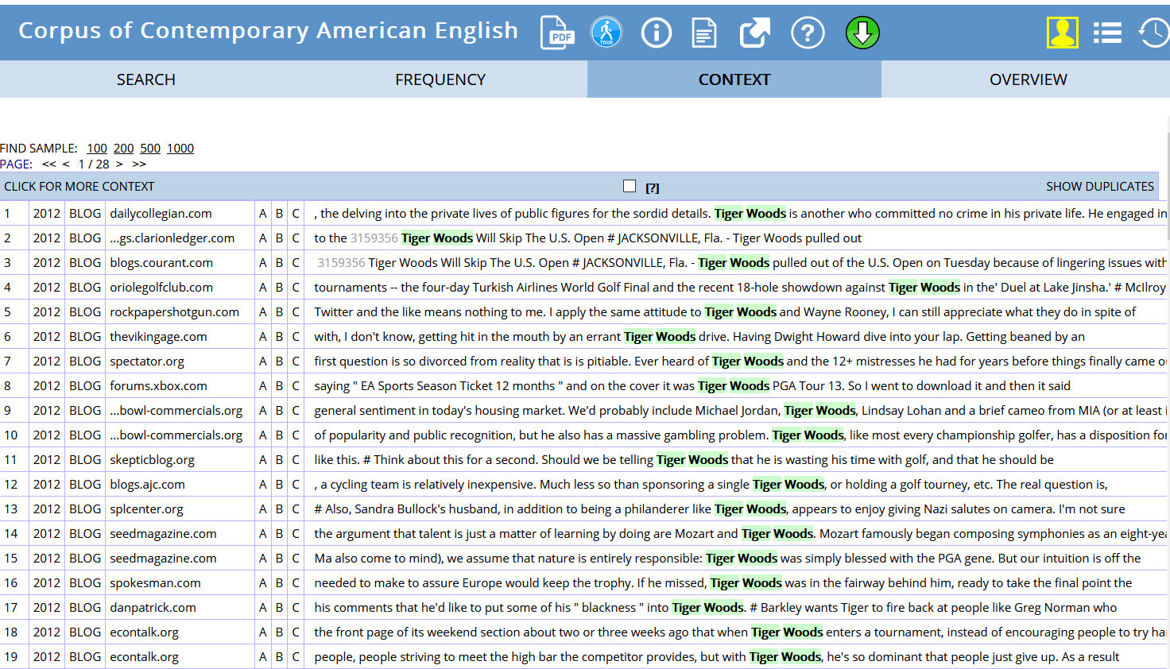

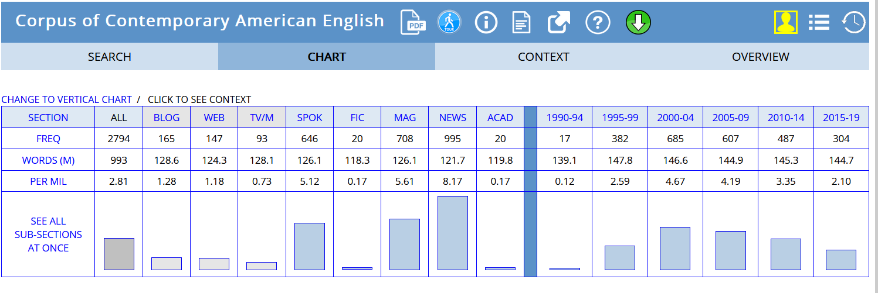

1. **Joe Montana**

Frequency of this word is 512

We can also analyse that, there are many sections where this name has been occurred like, in

BLOGs: 46 times

WEB: 20 times

TV/Media: 93 times

Spoken: 31 times

NEWS: 301 times

Academy: 0 times

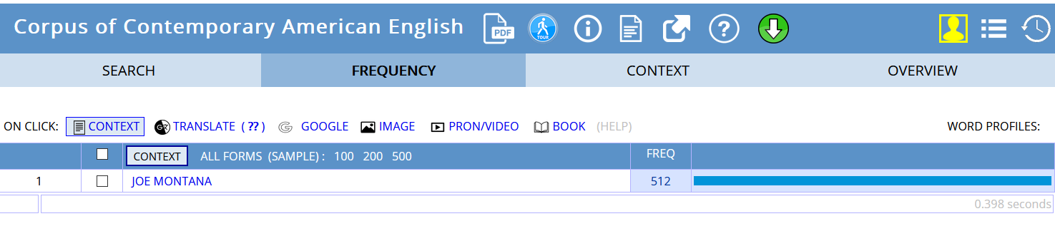

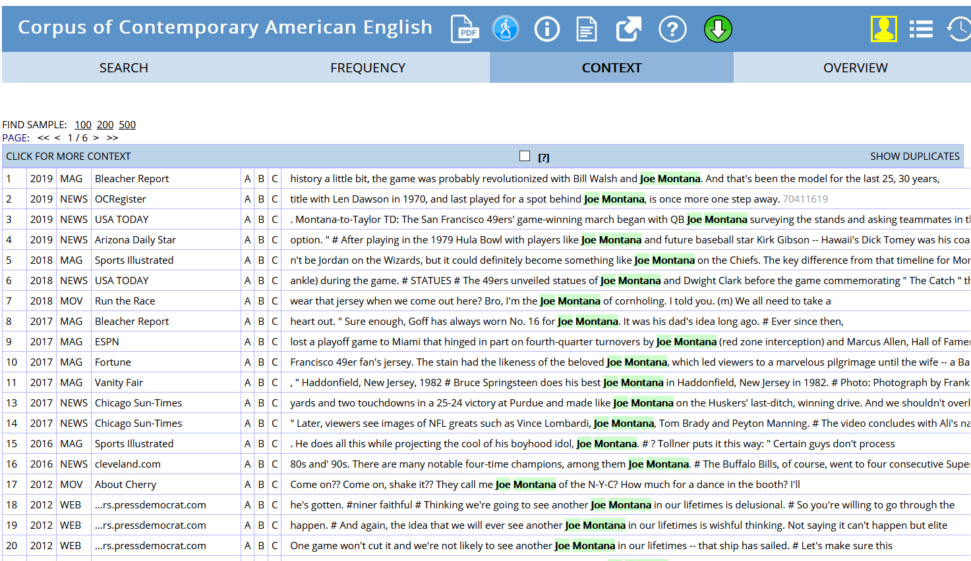

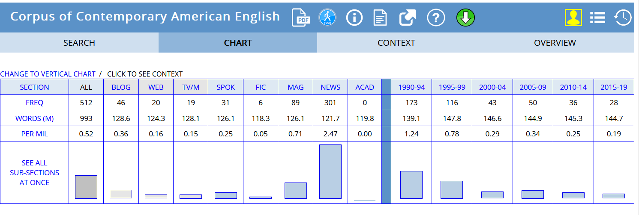

1. **Love**

Frequency of this word is 496929

BLOGs: 77909 times

WEB: 74982 times

TV/Media: 139095 times

Spoken: 59462 times

NEWS: 31938 times

Academy: 15049 times

